Create SU Table from a Form Filter
You can create a site unit table from a VPro data form using these steps.
You first need to filter your data form using the tools provided in Microsoft Access by first selecting the field you wish to filter and then click the funnel icon on the menu ribbon labeled “Filter”.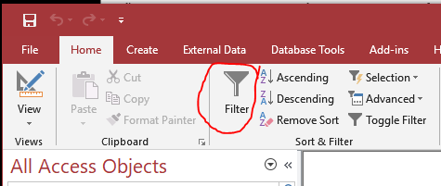
In the example below, I first selected the Zone field and then clicked the filter funnel. Access created a list box of the available data in that field. I then selected the zone I was interested in.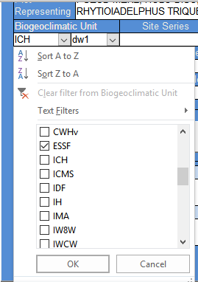
After selecting the zone I was interested in and clicking OK, I wanted to further narrow the list of plots by subzone. I placed my cursor in the subzone field and again clicked the filter funnel. Access presented a list box of available subzones.
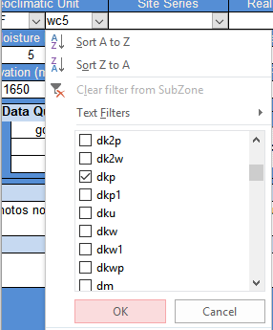

The status bar at the bottom of the form indicates that I have 123 filtered records.
Clicking the Create SU From Form Filter button opens the option form.
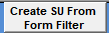
Here you can select whether you wish to create a new SU list or modify the current list. You can also include existing site unit assignments if you wish.
